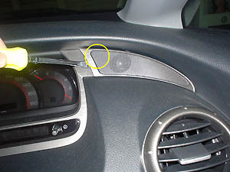 | Next is replacement of the tweeter.  The stay the original work it does other than 6 speaker cars  Because you think that there is a necessity, please note.  The genuine tweeter you use the lining peeling and remove.  Because there is a clip in the part of ○ sign  Putting out courage, the pulling [tsu] it pulls out densely. [uesu] and the like  The using damage that will try does not occur.
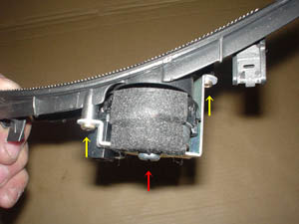 | Removing the coupler of the speaker line  When you remove the tweeter, the yellow arrow  Removing bis 2, the net part and the tweeter  The substance is separated. After that red arrow  Bis is removed.

1/2/3 | <- It returns, -> to the next

Already one going!
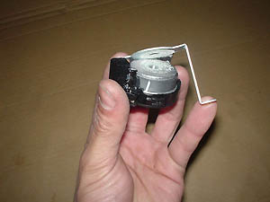 | The stay is peeled off from the tweeter itself.  Because it has been attached with the adhesive, deforming the stay  In order not to be able to point, paying attention, you remove.
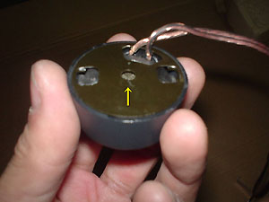 | In new tweeter installation base  It is to attach but this time in the hole of the arrow part  After putting the bis which you prepare the base  Try to attach.
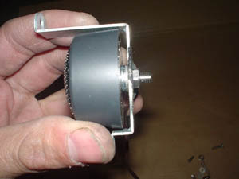 | It is new in the stay of the genuine tweeter  The tweeter is attached. In stay direct  When the tweeter is installed, the net part  Because it can designate the opening rather as between, temporary teaming up  The several you insert washers between the state and adjust  This please lock.
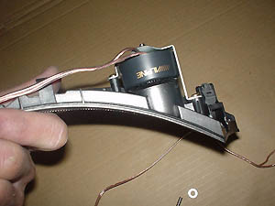 | New tweeter in net part  When it is installed. When you complete to here  Using the speaker cord/code of attachment  Dividing to speaker cord/code of audio  It makes be packed. The person and genuine Nabi that it is difficult,  When using the one-touch joint, genuine  The cord/code which is connected to the tweeter  Network cable of tweeter  Being able to connect, it is OK.
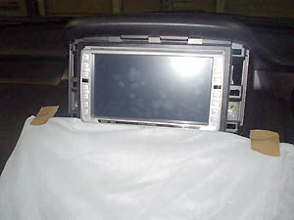 | In order divides the speaker cord/code and 込 to increase  Head unit is removed. Dash  Way the damage does not occur to the board, [uesu] and the like  You will spread.
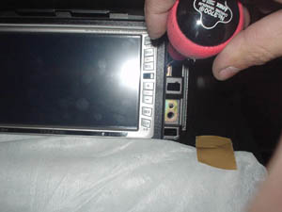 | To remove the framework of head unit, 4 bis  Removing, you pull out head unit.
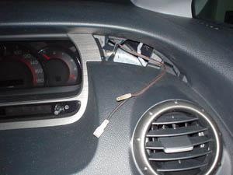 | The wire and the wire etc are used, the tweeter  Network cable to head unit  The line it does. Overstraining, pulling  That wiring and the other equipment are not damaged, you note!
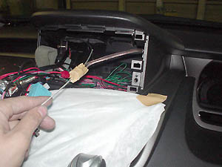 | When to be good the line it is possible, the head unit reverse side  It makes the speaker output terminal interrupt.  The instruction manual which has belonged to the speaker  Seeing carefully, way you do not make a mistake left and right and in polarity,  You will connect.
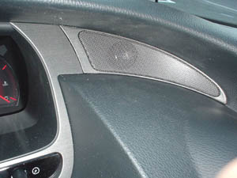 | To turn the key and operate the stereo, sound  It checks whether it comes out. When it has come out properly  Inserting the tweeter as before, it is completion.  You exchange also suicide seat side in the same manner.

1/2/3

