Honda Integra 1993 DC2, Passenger foot well water leak, rust holes above windscreen under sielastic.
Holes in DC2, between top of windscreen and roof, under black sielastic and cover molds, that leak into cabin across plastic ceiling and down passenger A pillar exiting adjacent to fresh air intake of heater box.
Remove cover molds using wide screwdriver and cardboard protection on A pillars and roof, exposing sielastic.
Easy to remove sielastic as rust on base, and cracks on roof side leave little adhesion in the sielastic, just cut using box cutter and glass window edge as a template.
Rust holes and rust in DC2 between top of windscreen and roof, after removing black sielastic. I found much less rust on window sides, but was keen to reseal them as well.
Clearly the water was allowed in by cracked si elastic but trapped in the section across top of windscreen (causing rust holes then leaks) but indicating si elastic in full contact directly under glass which would have let the water out, additionally no water running down inside of screen. Thus window fully attached.
Test window by carefully trying to push it out, I had no movement and was happy to just re sielastic to seal around window after treating rust.
Thus windscreen is solidly connected, and doesn't need removal, risking cracking windscreen.

Holes and rust in DC2 between top of windscreen and roof, after removing black sielastic. I found less rust on sides.
This area not visible after repair, no paint matching generally needed. In my case rust extended onto roof, I used matching paint there only and any enamel I had in the U section.

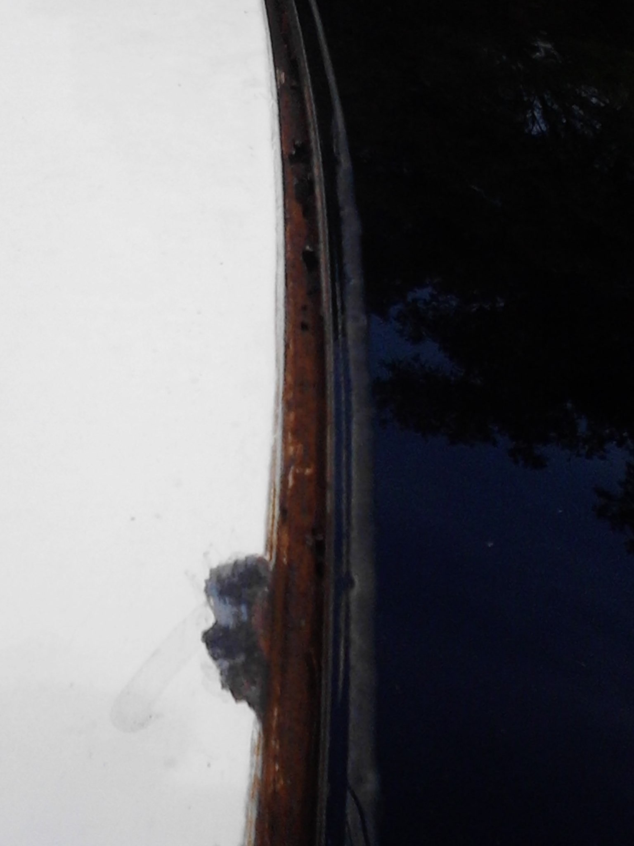

Note, I did not replace the joint cover molds and just used the black sielastic finish, which typical of modern cars and suits my daily second car. If you reuse the molds or buy new ones, you can take less care and push the molds into place when sielastic is wet, taping them down until dry and get the original look.
You need dry weather or a garage, box cutter, small screwdriver/scrapper, masking tape, black sielastic, rust converter, undercoat and enamel top coat, 3 very small paint brushes 3 to 5 mm wide (throw away after uses).
Time 30 minutes, every 4 days the rest is drying time between coats.
After scraping down the top and sides of the window with screwdriver to remove loose rust and residual sielastic, blowing out rust (just exhale rapidly or using a dry paint brush) , using rust converter 6hrs drying, undercoat and 2 coats of enamel and allowing to fully dry, I have a reliable surface to re sielastic, on top and sides of Front windscreen.
Bought Black window si elastic, at Bunning's $5.50, bought 2 used one. Tape the window and the roof (and sides) with masking tape, cut nozzle to fit in between top of window and roof, then layed two layers at top of window and around bend.
I then smoothed out the si elastic with a wet finger, to firmly push it down and form a curve, add more and redid as necessary ( two points). This seals the treated rust holes and the entire area. I general use a bit more silastic then you think and do the smoothing once, the more you touch it the worse it looks.
Then I did the same paint and sielastic the sides down to the bottom of the windscreen at the same time.
Finish minor touchups, Remove masking tape while sielastic still wet, gives nice lines with little mess.

Finished look, being black is not that visible and it cost say $20.
If you need a better look, you still need to fix the leak as described, but replace the cover molds, pressing the attachments into the sielastic (and temporarily taping) so it's completely hidden.
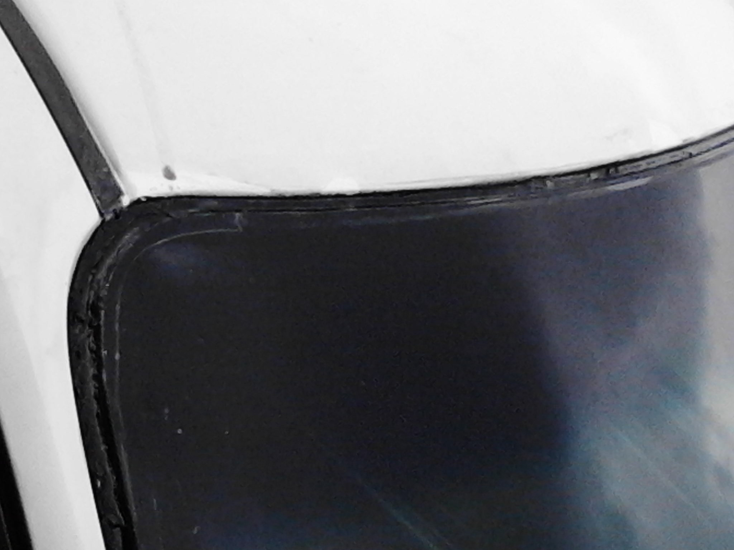

After all painting prior to sielastic, dark ovals in U are rust holes on the left of middle RH drive (oppose on LHD due to opposite road camber?). The water will run down hill across inside plastic roof molding to passenger side when parked in gutter but can run to drivers side if camber put that side down hill, through A pillar.

